MODEL EXAM – 2(PRACTICAL)

EXPERIMENT – 1.

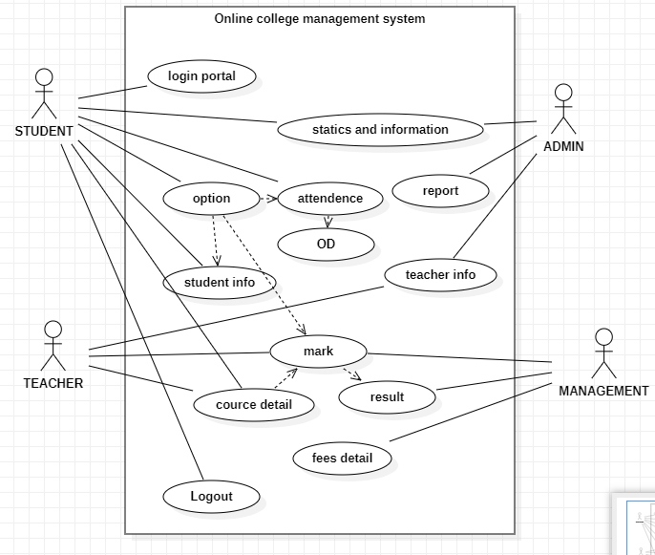

EXPERIMENT – 2.

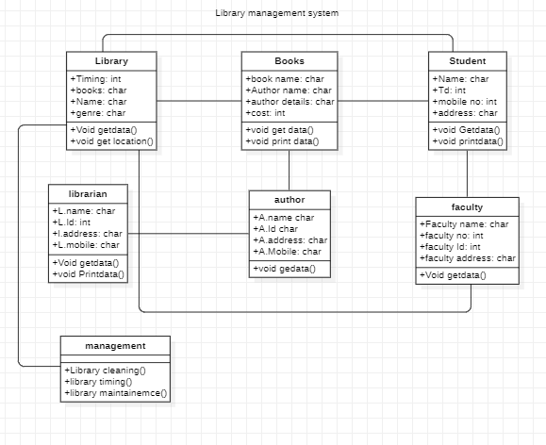

EXPERIMENT – 3.

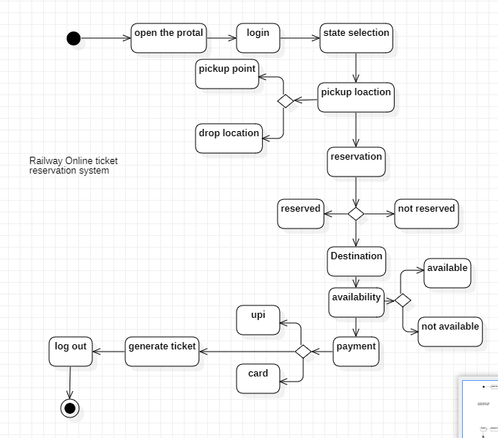

EXPERIMENT -4.

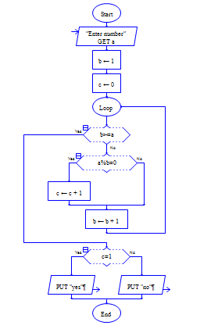

OUTPUT:

